Evolution, Part Two

Homologous and Analogous Traits

Both sugar gliders and flying squirrels have flaps of skin that allow them to glide. Is this a homologous or analogous trait?

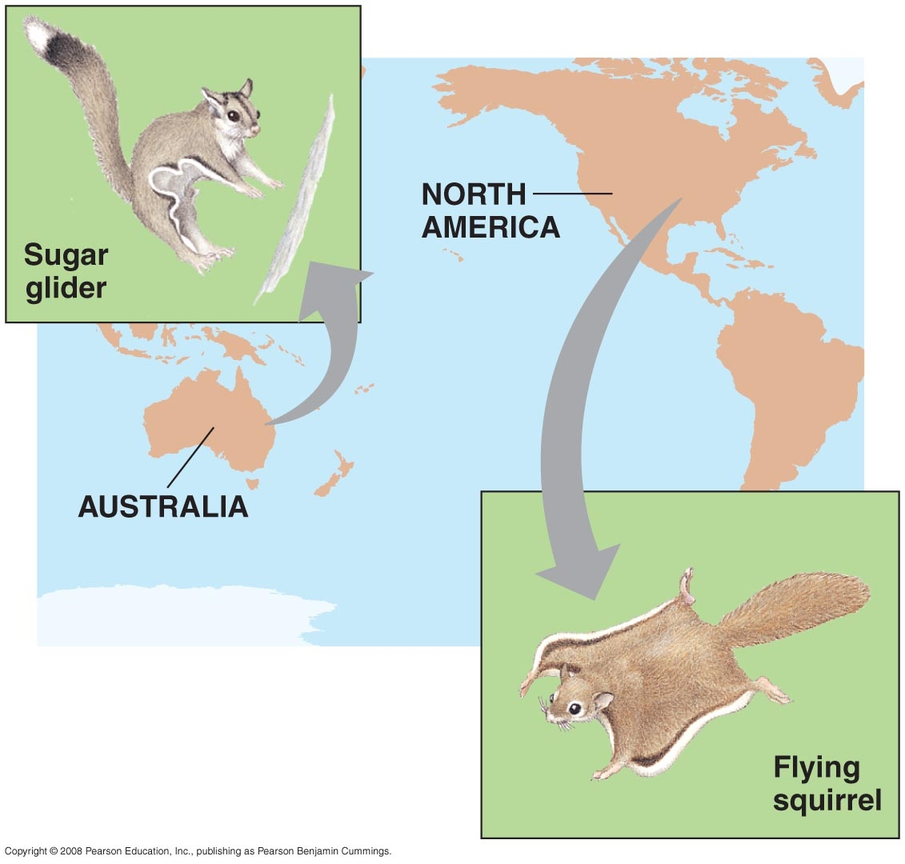

Cacti are members of the family Cactaceae and are native to the New World. Succulent euphorbs are members of the family Euphorbiaceae and most are native to the Old World. Both groups of plants are xerophytes, plants adapted to living in arid environments. They store water and carry out photosynthesis in their stems. Most have spines, which are modified leaves.

Are these traits homologous or analogous?

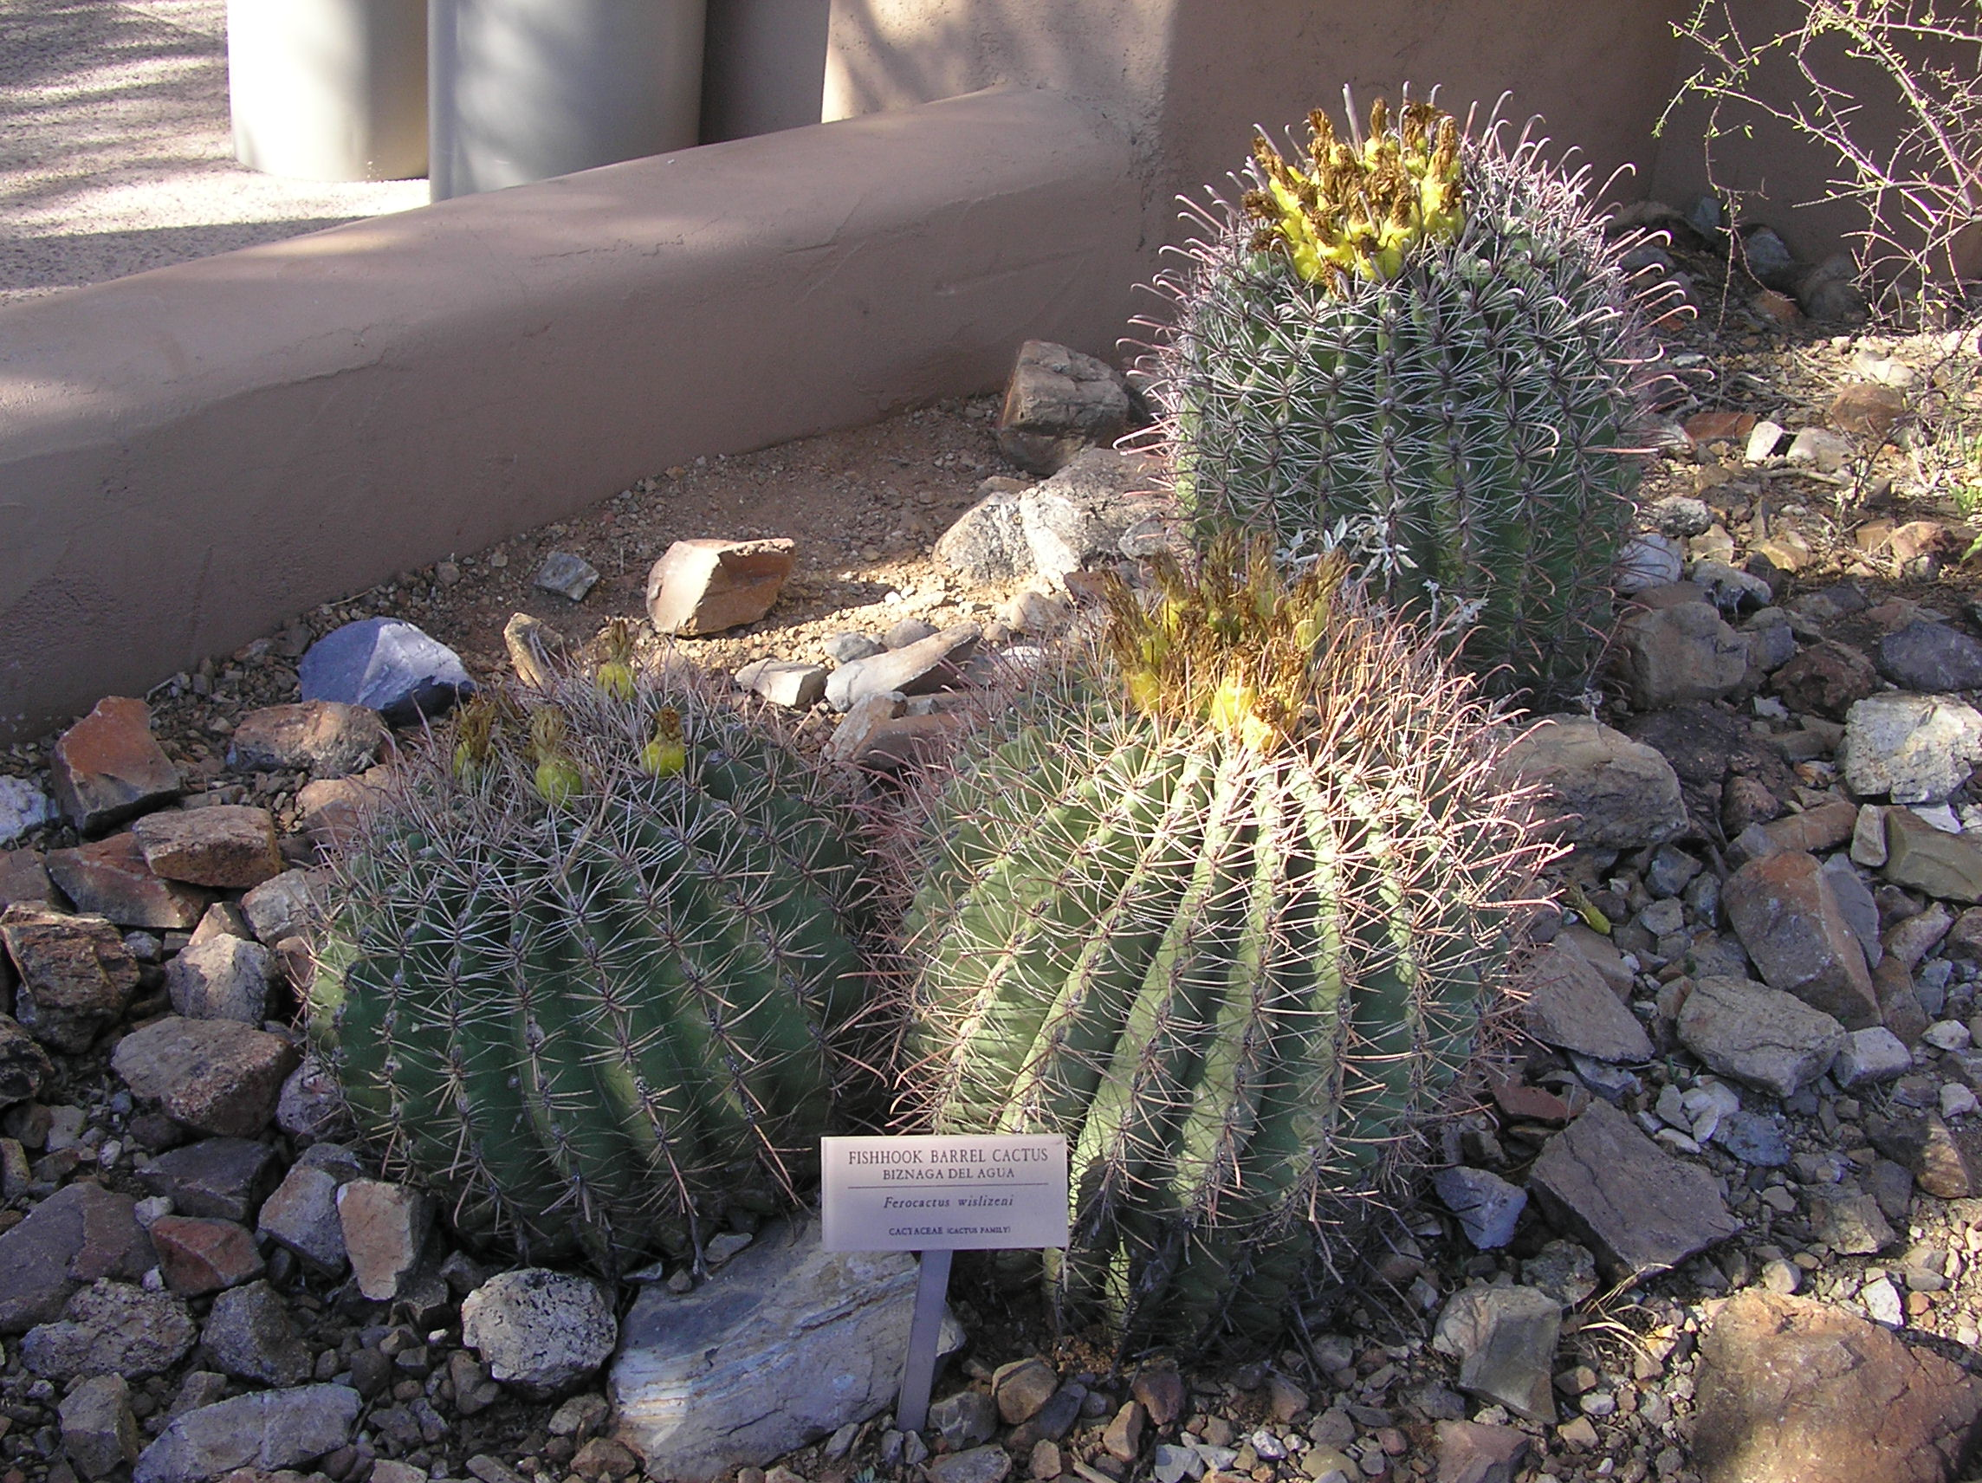
Cactus Photo Credit: Isantry, 2006, Wikimedia Commons

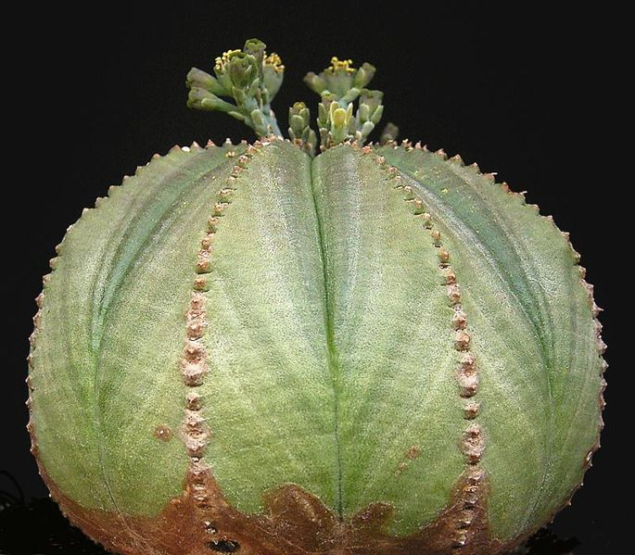
Euphorb Photo Credit: Frank Vincentz, 2006, Wikimedia Commons

